**1. Write a program that takes a student's score as input and outputs the corresponding grade based on the following scale:**

A: 90-100

B: 80-89

C: 70-79

D: 60-69

F: 0-59

**CODE**

**package** sco;

**import** java.util.Scanner;

**public** **class** score {

**public** **static** **void** main(String[] args) {

Scanner scanner = **new** Scanner(System.***in***);

System.***out***.print("Enter the score: ");

**double** score = scanner.nextDouble();

String grade = *getGrade*(score);

System.***out***.println("The grade is: " + grade);

}

**public** **static** String getGrade(**double** score) {

**if** (score >= 90 && score <= 100) {

**return** "A";

} **else** **if** (score >= 80 && score < 90) {

**return** "B";

} **else** **if** (score >= 70 && score < 80) {

**return** "C";

} **else** **if** (score >= 60 && score < 70) {

**return** "D";

} **else** **if** (score >= 0 && score < 60) {

**return** "F";

} **else** {

**return** "Invalid score";

}

}

}

**OUTPUT**

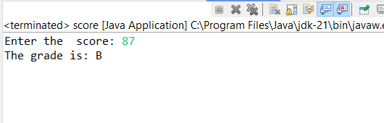

**2. Write a program to check if a given year is a leap year. (A year is a leap year if it is divisible by 4 but not by 100, or it is divisible by 400.)**

**CODE**

**package** y;

**import** java.util.Scanner;

**public** **class** year {

**public** **static** **void** main(String[] args) {

Scanner scanner = **new** Scanner(System.***in***);

System.***out***.println("Enter number");

**int** year = scanner.nextInt();

**boolean** isLeapYear = *checkLeapYear*(year);

**if** (isLeapYear) {

System.***out***.println(year + " is a leap year.");

} **else** {

System.***out***.println(year + " is not a leap year.");

}

}

**public** **static** **boolean** checkLeapYear(**int** year) {

**if** (year % 400 == 0) {

**return** **true**;

} **else** **if** (year % 100 == 0) {

**return** **false**;

} **else** **if** (year % 4 == 0) {

**return** **true**;

} **else** {

**return** **false**;

}

}

}

**OUTPUT**

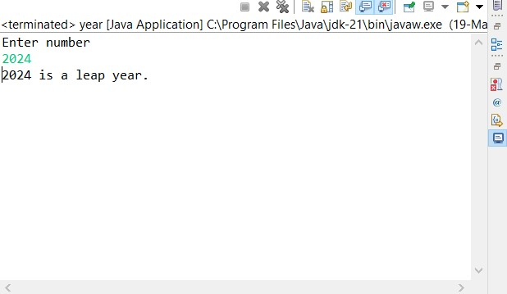

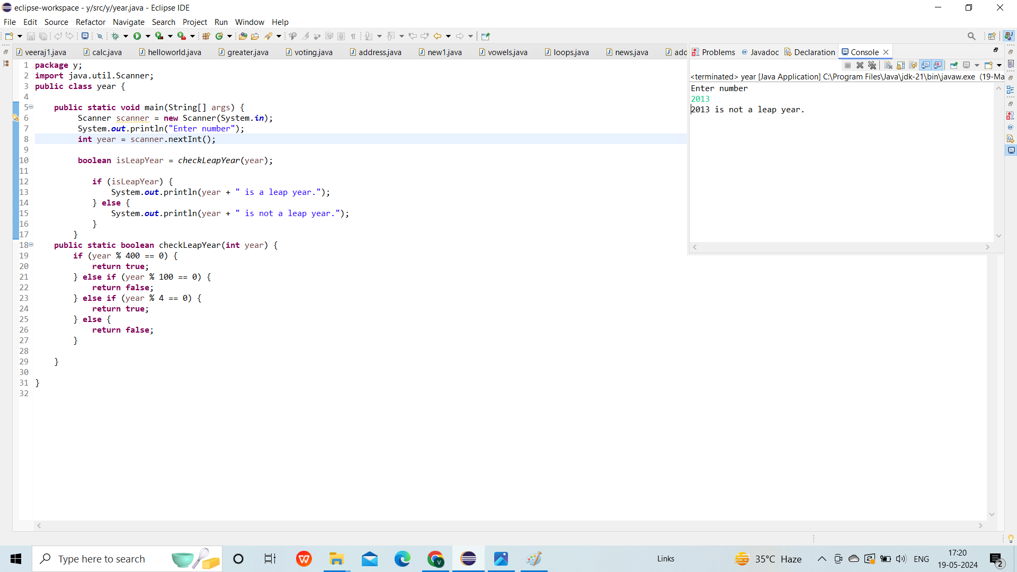

**3. Write a program that takes an integer as input and checks if it is positive, negative, or zero.**

**CODE**

**package** number;

**import** java.util.Scanner;

**public** **class** numbers {

**public** **static** **void** main(String[] args) {

Scanner s = **new** Scanner(System.***in***);

System.***out***.println("Enter in");

**int** number = s.nextInt();

**if**(number > 0)

{

System.***out***.println("this postive");

}

**else** **if**(number<0)

{

System.***out***.println("this is negative");

}

**else**{

System.***out***.println("this is zero");

}

}

}

**OUTPUT**

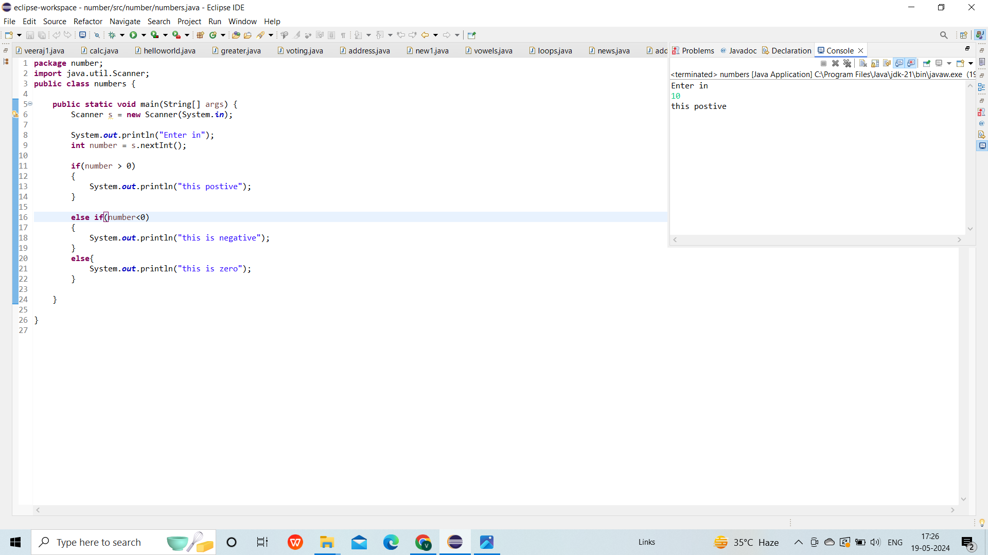

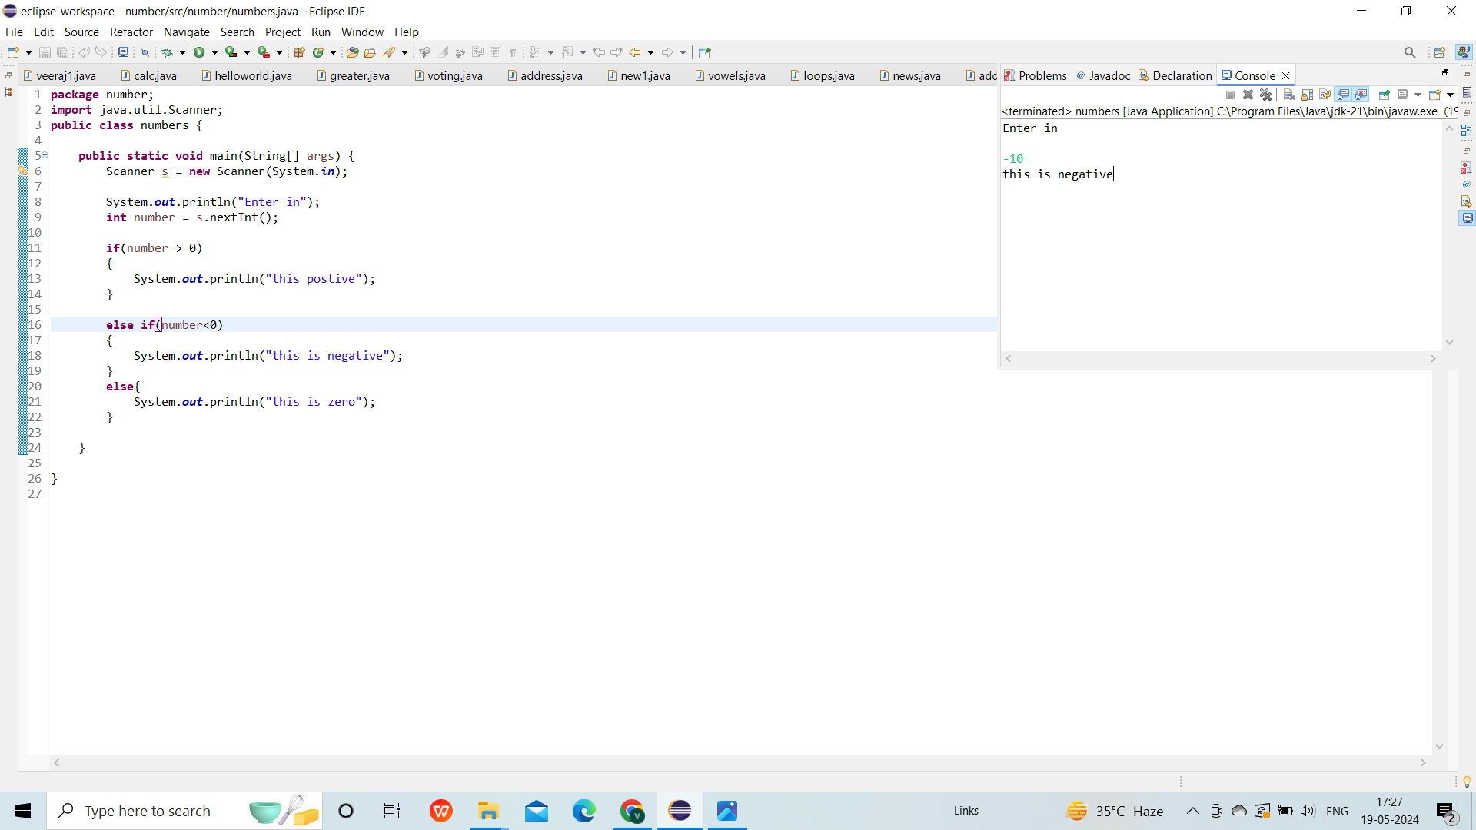

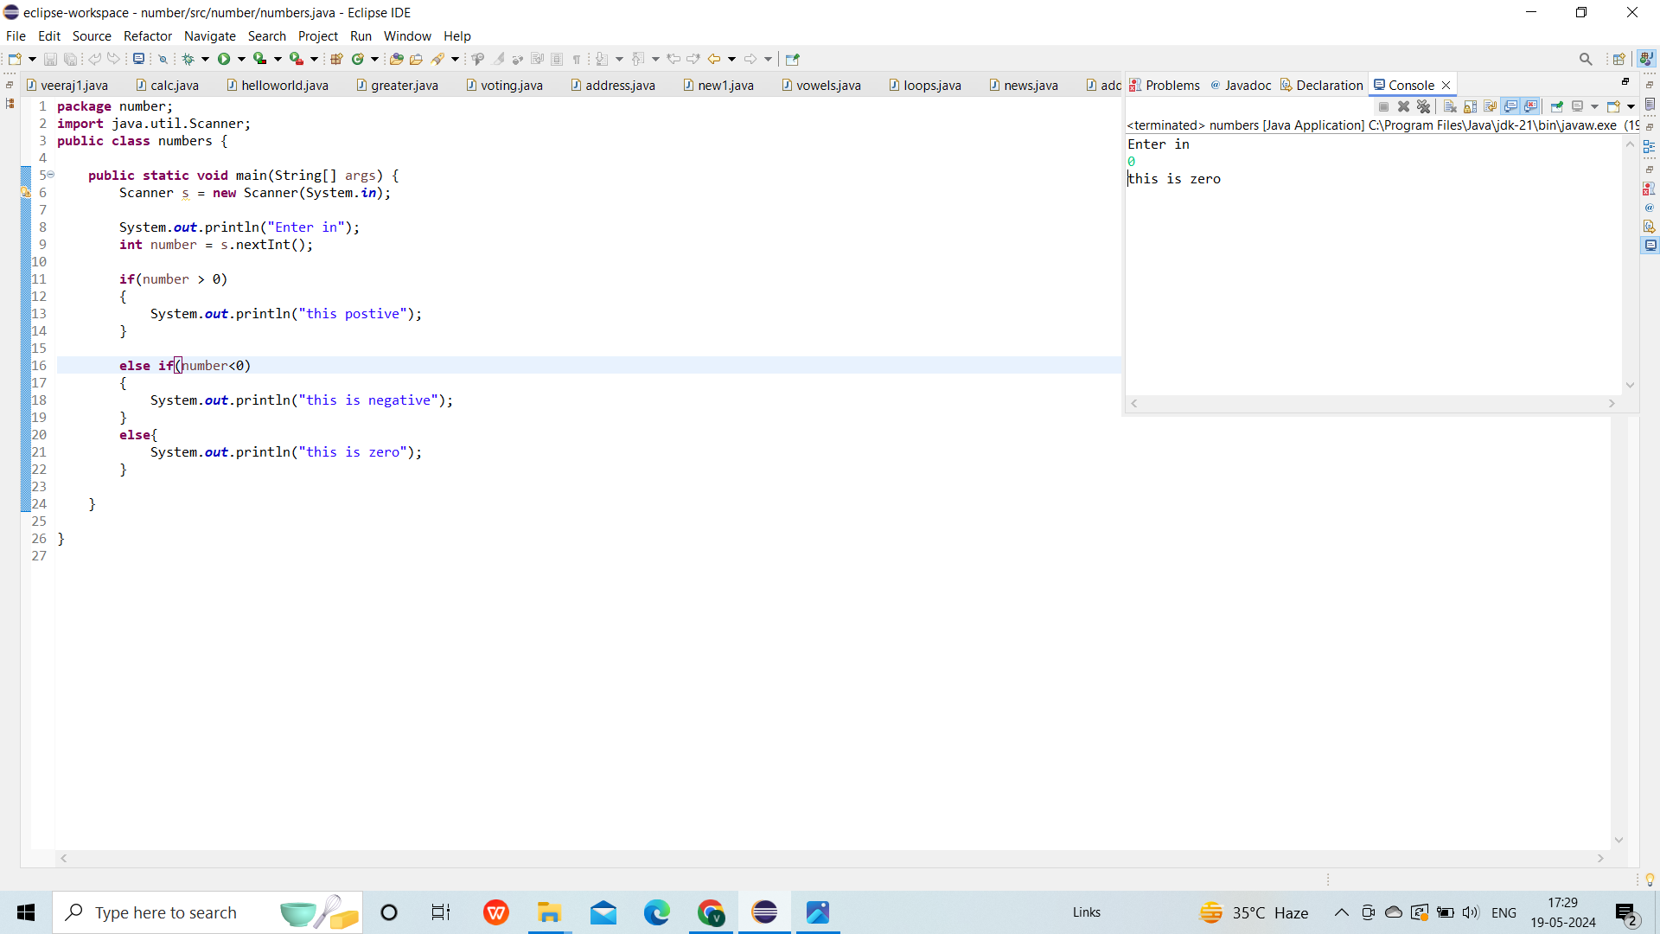

**4.Write a program that prints numbers from 1 to 10 using a loop.**

**CODE**

**package** loop;

**public** **class** loops {

**public** **static** **void** main(String[] args) {

**for**(**int** i=1;i<=10;i++)

{

System.***out***.println(i);

}

}

}

**OUTPUT**

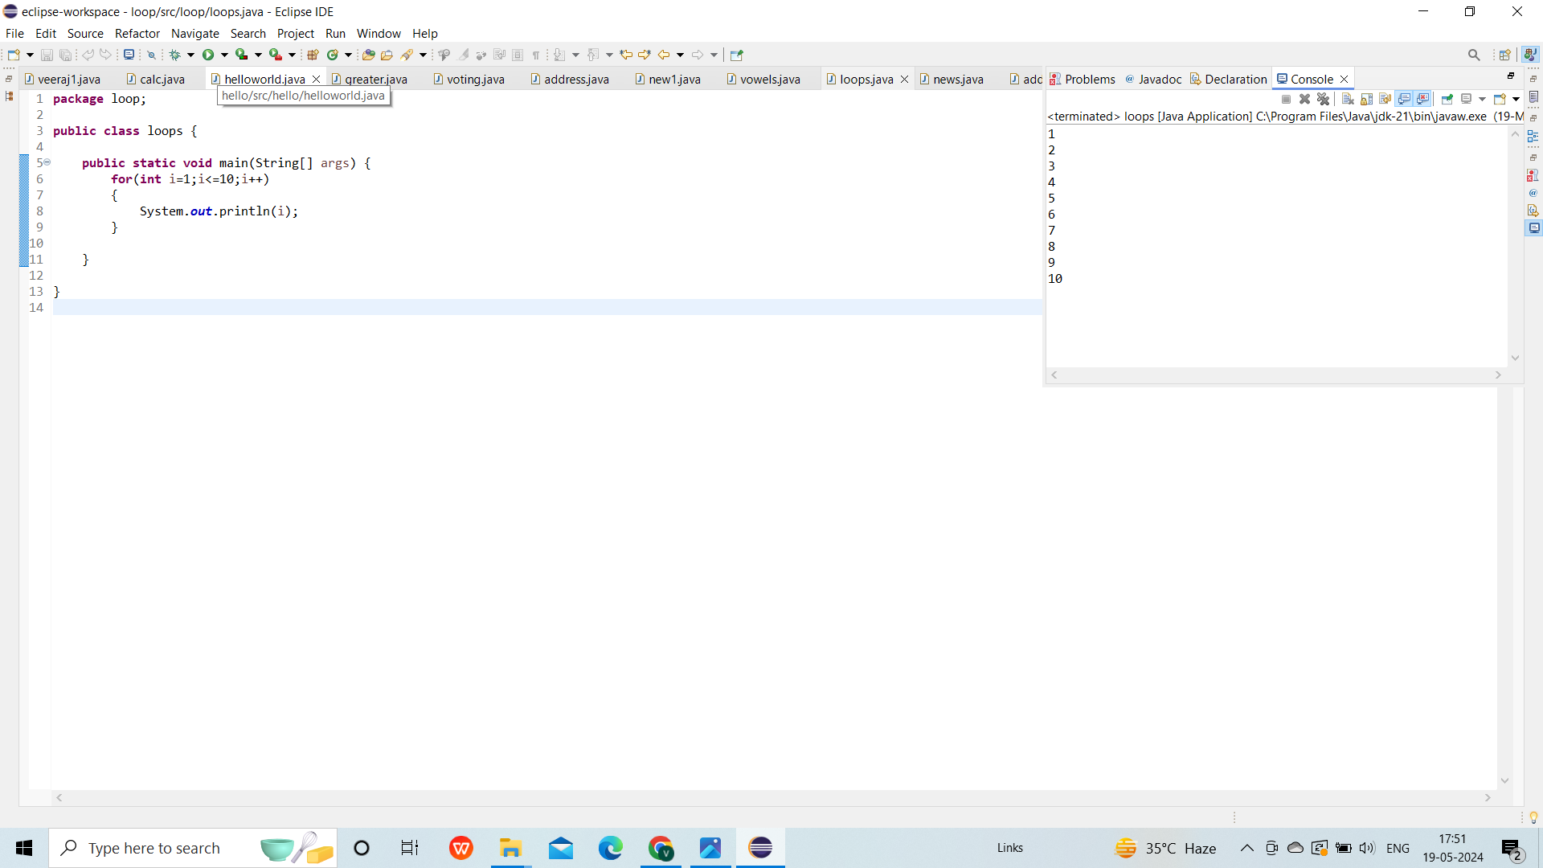

**5.Write a program that takes an integer N as input and calculates the sum of entered numbers.**

**CODE:**

**package** sum;

**import** java.util.Scanner;

**public** **class** sums {

**public** **static** **void** main(String[] args) {

Scanner scanner = **new** Scanner(System.***in***);

System.***out***.print("Enter the number of values you want to sum: ");

**int** N = scanner.nextInt();

**int** totalSum = 0;

**for** (**int** i = 0; i < N; i++) {

System.***out***.print("Enter number " + (i + 1) + ": ");

**int** number = scanner.nextInt();

totalSum += number;

}

System.***out***.println("The sum of the entered numbers is: " + totalSum);

}

}

**OUTPUT**

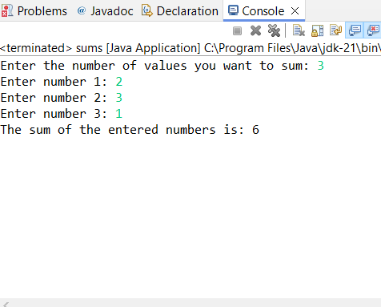

**6.Write a program that takes an integer as input and prints its multiplication table up to 10**

**CODE**

**package** mul;

**import** java.util.Scanner;

**public** **class** multi {

**public** **static** **void** main(String[] args) {

Scanner s = **new** Scanner(System.***in***);

System.***out***.println("enter number");

**int** number = s.nextInt();

System.***out***.println("Multiplication table for " + number + ":");

**for** (**int** i = 1; i <= 10; i++) {

System.***out***.println(number + " * " + i + " = " + (number * i));

}

}

}

**OUTPUT**

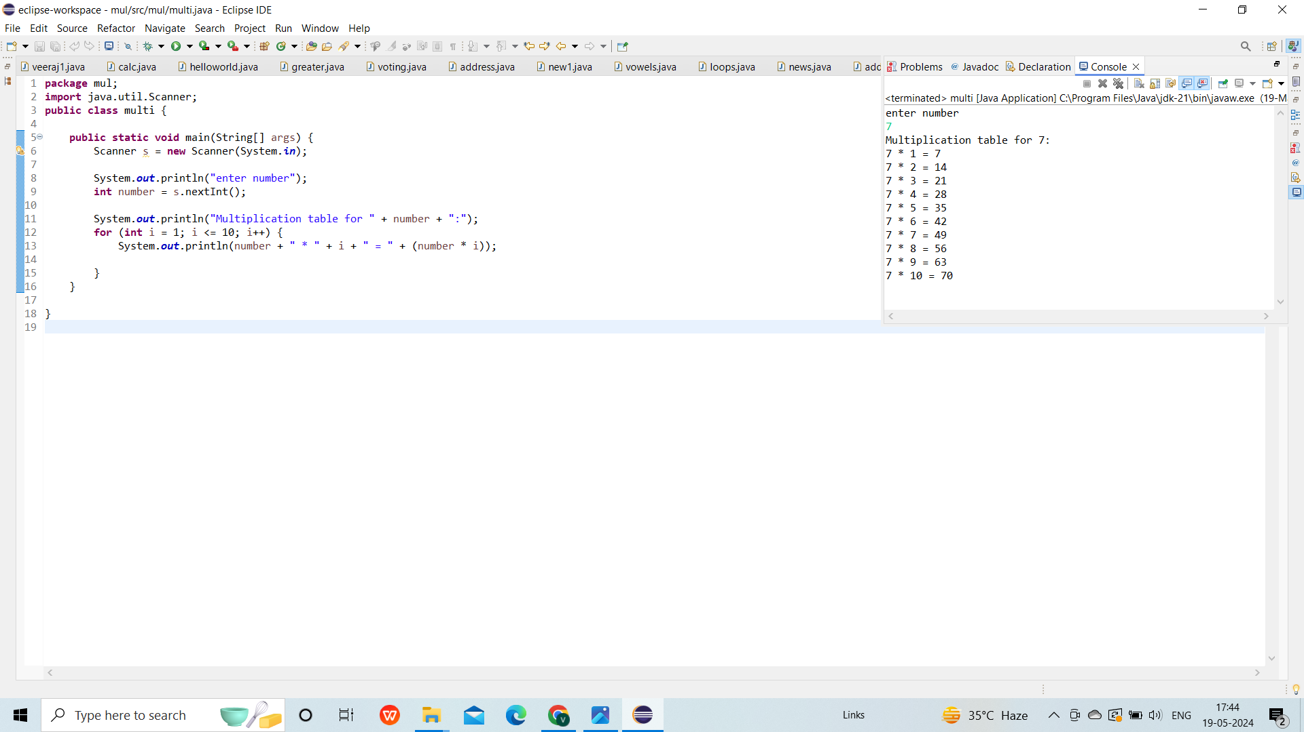

**7.Write a program that takes a positive integer as input and prints its digits in reverse order.**

**CODE**

**package** rev;

**import** java.util.Scanner;

**public** **class** reverse {

**public** **static** **void** main(String[] args) {

Scanner scanner = **new** Scanner(System.***in***);

System.***out***.print("Enter a positive integer: ");

**int** number = scanner.nextInt();

**if** (number < 0) {

System.***out***.println("Please enter a positive integer.");

} **else** {

System.***out***.print("Reversed digits: ");

**while** (number > 0) {

**int** digit = number % 10;

System.***out***.print(digit);

number /= 10;

}

System.***out***.println();

}

}

}

**OUTPUT**

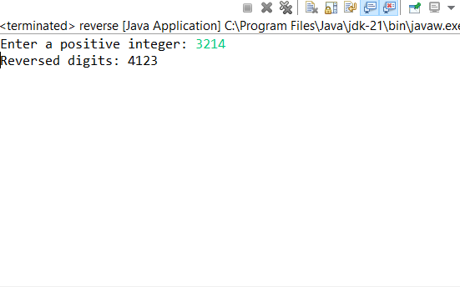

**8. Create a class Animal with a method makeSound() that prints "Some generic animal sound". Create another class Dog that extends Animal and overrides the makeSound() method to print "Bark". Write a main method to demonstrate calling the makeSound() method on an Animal reference holding a Dog object.**

**CODE**

**package** work;

**class** Animal{

**void** makeSound(){

System.***out***.println("Some generic animal sound");

}

}

**class** Dog **extends** Animal{

**void** makeSound(){

System.***out***.println("bark");

}

}

**public** **class** veeraj {

**public** **static** **void** main(String[] args) {

Dog d=**new** Dog();

d.makeSound();

d.makeSound();

}

}

**OUTPUT**

